**Tidal Energy at Seaweed Farms Workbook**

**Name: ________________**

**Seaweed and its Uses**

Seaweed is a plant that lives in the water. It can grow in salty seawater or fresh water from rivers or lakes. Unlike land plants, seaweed does not have roots, stems, or leaves. Instead, it has a part called a holdfast that helps it stick to rocks or sand.

Just like plants on land, seaweed needs sunlight and food to grow. It uses the sun’s light to make food for itself in a process called photosynthesis. During this process, seaweed uses up carbon that is bad for our planet and gives off air we can breathe. Seaweed can be different colors like green, brown, or red. It is important because it gives food and shelter to many water animals.

People can farm seaweed just like they farm plants on land. Farmers plant little seaweed plants on ropes that go in the water. The seaweed grows on the ropes and the farmer pulls up the rope to collect the seaweed when it’s ready. This is good for the ocean because seaweed helps clean the water. Seaweed is very useful. People and farm animals can eat it, and it can be used to make medicine and even makeup!

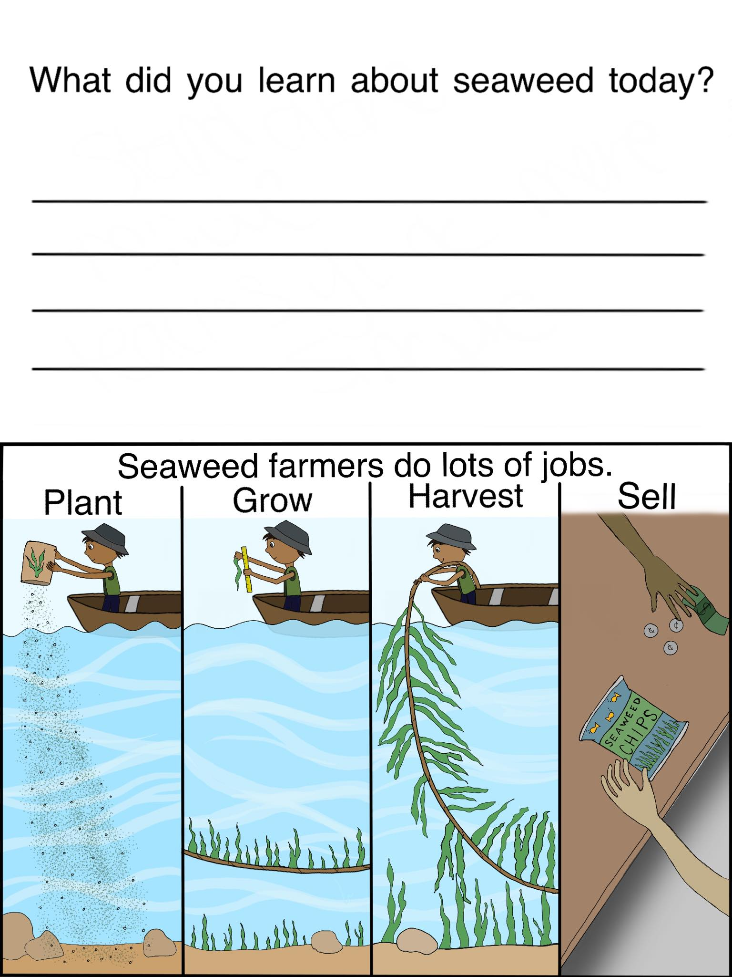

**Life at a Seaweed Farm**

Seaweed is like a superhero of the sea! Many sea animals, both big and small, need seaweed for their daily lives. Some animals like sea snails eat seaweed. Other animals like fish live around seaweed because it keeps them safe. But that’s not all! Seaweed also helps keep the ocean clean. It does this by soaking up things in the water that can be harmful to other sea life.

Just like how trees are grown on farms, seaweed can be grown on farms too! These farms are underwater, and they do many important jobs. A seaweed farm is like a big underwater forest where many creatures live. You might find all sorts of animals there. Birds, otters, fish, oysters, sea snails, crabs, sea stars, and even spiky sea urchins like to live at seaweed farms!

Seaweed plays a big role in keeping our oceans healthy and full of life!

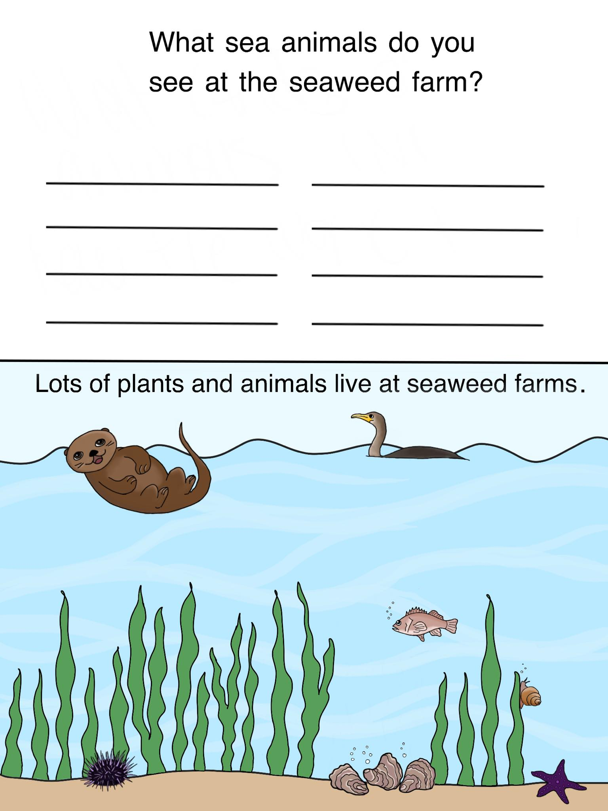

**Tides**

Tides are like a big wave that goes around the Earth two times each day. They happen because of the moon and the sun.

The moon and the sun are like giant magnets pulling on the Earth. But instead of pulling everything, they mostly pull on the water in our oceans. This is because water can move around much more easily than land can.

When the moon is over an ocean, it pulls the water towards it. This causes the water to rise. The time when the water is at its highest is called high tide. In between high tides, the water spreads back out and water gets lower. This is when we have low tides.

The sun also pulls on our oceans and makes tides. But because the sun is so far away, its pull is not as strong as the moon’s. When the sun and moon line up, their pulls add together to make extra high and extra low tides.

So, tides are changing water depths around our planet caused by the pulls of the moon and sun. They are part of what makes our Earth such a wonderful place to live!

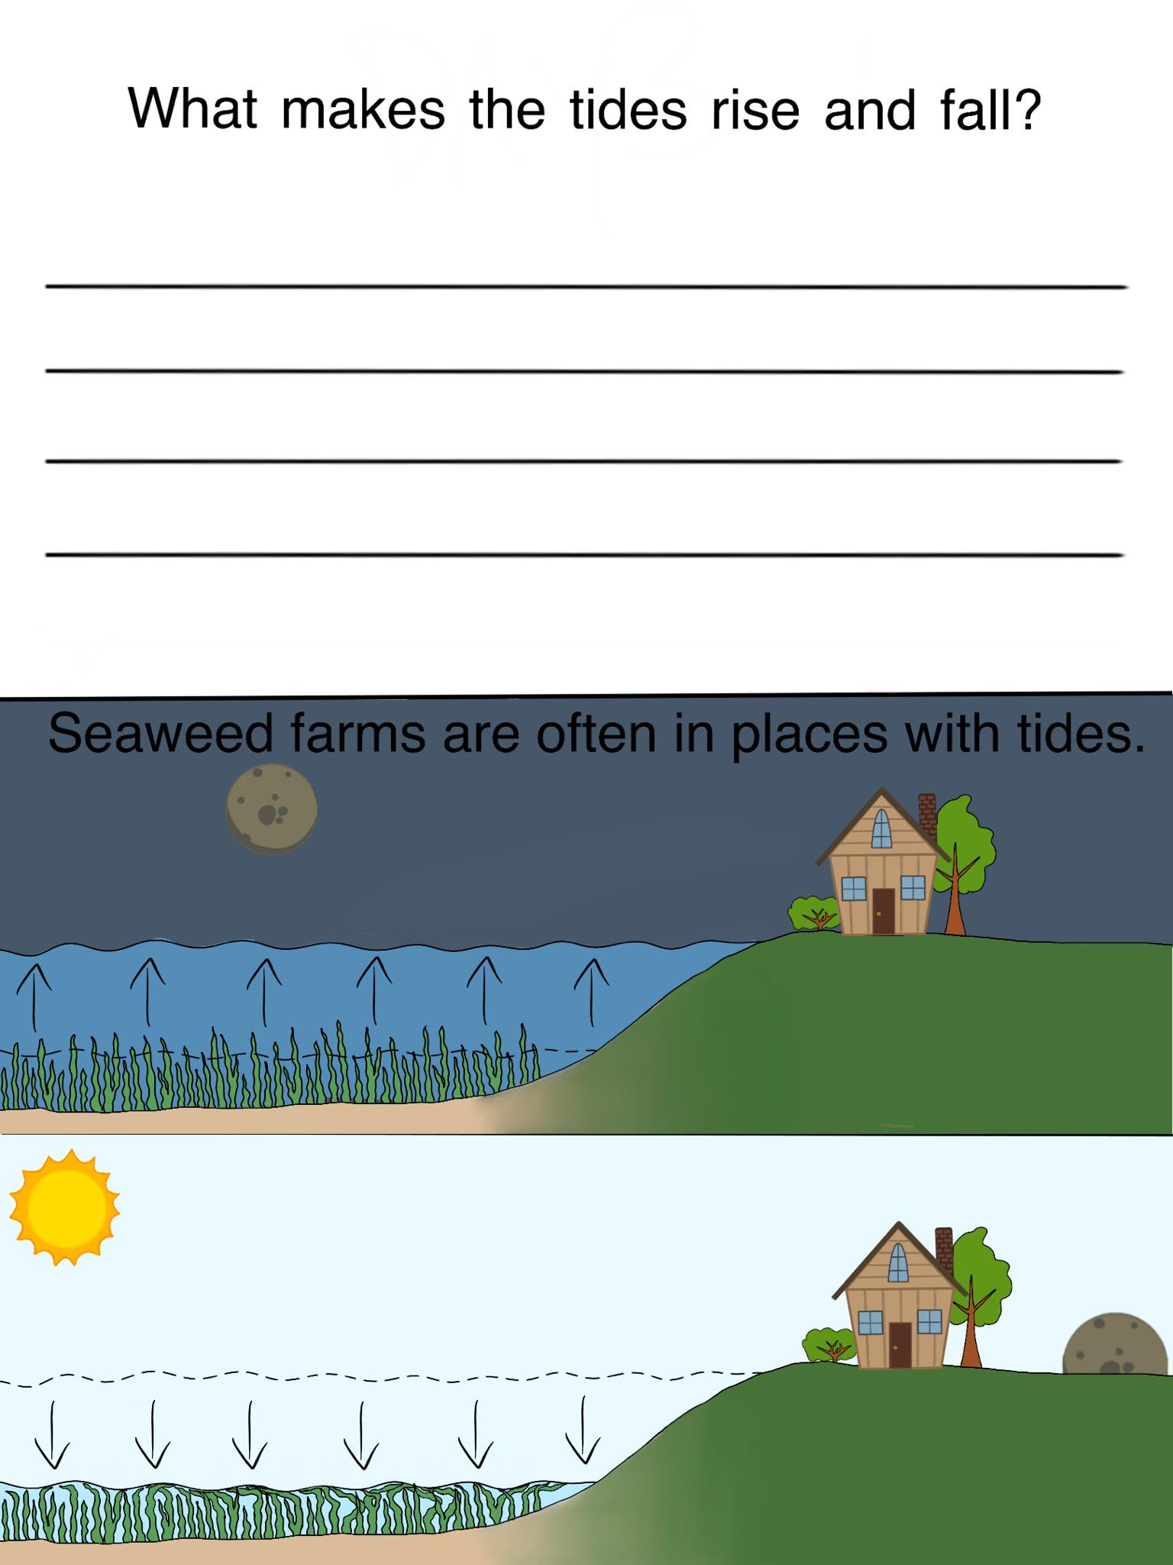

**Tidal Energy at Seaweed Farms**

The water depth at seaweed farms can change a lot because of the tides. When the tide comes in and out, the water can move fast. We can use this moving water to make electricity!

A tidal turbine is like a big underwater pinwheel. When you blow on a pinwheel, it spins around. The same thing happens with a tidal turbine. When the fast-moving water pushes against it, it spins around. This spinning is used to make electricity.

This electricity can be helpful for the seaweed farmer. It can be used to power lights, boats, and other tools needed to grow and take care of the seaweed. But it’s not just good for the farmer. People living near the ocean can use this electricity too! It can power homes, schools, and businesses.

The best part is power from tides is good for Earth. Tides happen every day so we can count on them for our power. Power from tides does not dirty the air like burning coal or gas does.

Tidal turbines at a seaweed farm can do two great things at once. They can help the farmer grow seaweed and make electricity for people to use!

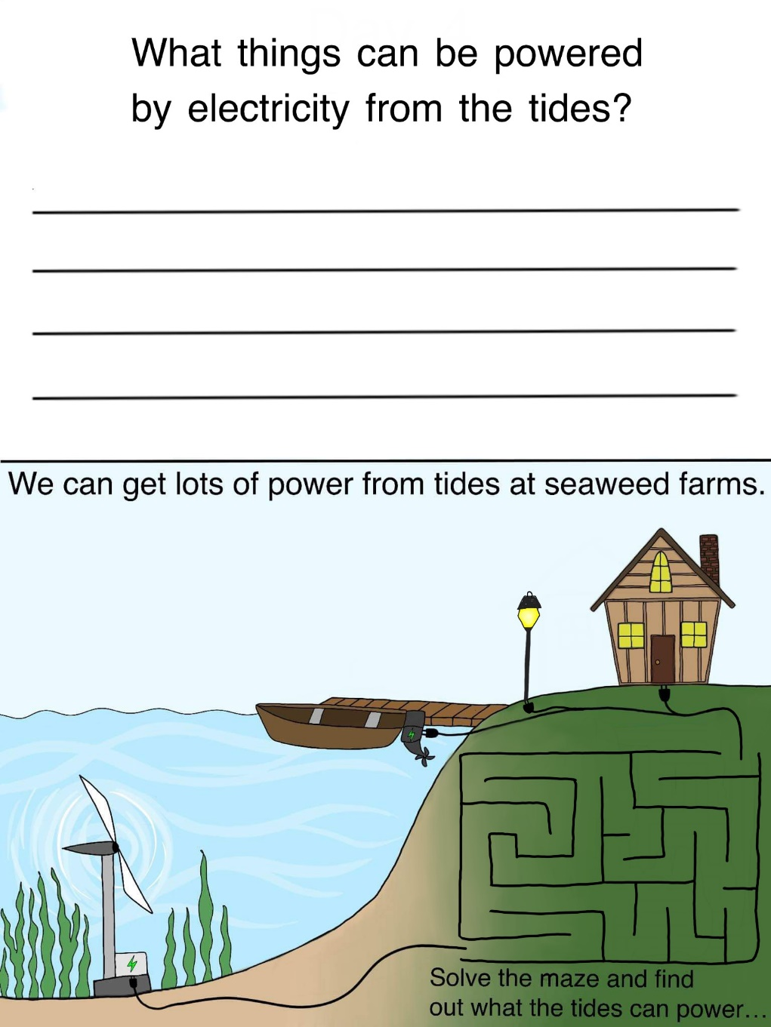

**Complete Story**

Seaweed is a plant that lives in the water in oceans and lakes. We can also grow seaweed farms. A seaweed farm is not just a place for growing seaweed, but also a home for many sea creatures. More plants and animals are better for the Earth.

Seaweed is great because it can take in carbon that is not good for our planet. Then, as it grows it gives off air which we need to breathe. This helps clean our air!

Seaweed farms also help clean up the water they grow in. The seaweed can soak up things in the water that harm other plants and animals. This helps clean our water!

Seaweed farms have changes in water depth called tides. We can make electricity from these tides to power lights, boats, tools, and houses.

Making power from tides at a seaweed farm makes the farmer happy and nature happy. The farmer is happy because their seaweed is healthy, and they have electricity. Nature is happy because the air and water is clean and there is food and homes for sea creatures.

