See which procedures use this document

Authorized Worker Lockout and Tagout Devices
- Authorized worker lockout devices are green. Since there may be multiple energy sources involved, multiple lockout devices that are all are keyed alike can be issued as a set to each authorized worker. It is recommended that authorized workers identify assigned lockout devices with their name.
- Lockout devices may be obtained from the Lockout and Tagout Material Coordinator.

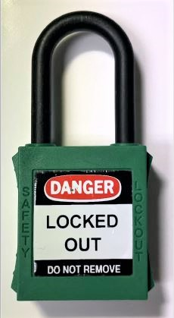

Figure 1. Example of an Authorized Worker Lockout Device
- Authorized worker tags use individual “Danger” tagout devices. The tag signifies that an authorized worker is working on a system or component. The tagout device is installed by the authorized worker before starting work and is removed when the authorized worker leaves that work assignment.
- “Danger” tagout devices are durable and reusable.
- Replacement “Danger” tagout devices may be obtained from the Lockout and Tagout Material Coordinator. Stock number 54-6001-995 (07/96).
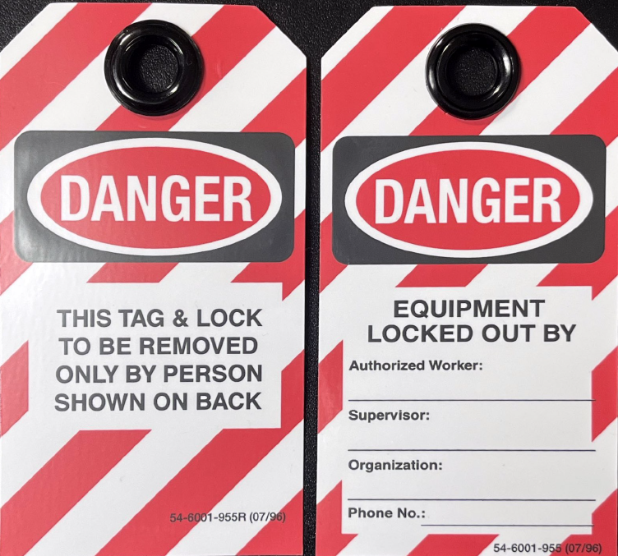

Figure 2. Example of an Authorized Worker “Danger” Tag

Controlling Organization Lockout and Tagout Devices
- Controlling organization lockout devices are red.
- These lockout devices may be obtained from the Lockout and Tagout Material Coordinator.
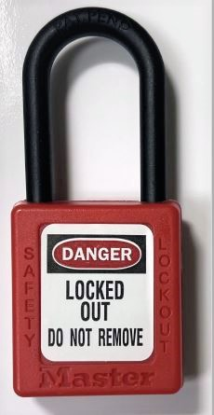

Figure 3. Example of a Controlling Organization Lockout Device
- The controlling organization uses “Danger: Do Not Operate” tagout devices.
- “Danger: Do Not Operate” tagout devices are durable and reusable.
- Replacement “Danger: Do Not Operate” tagout devices can be ordered from the PNNL Duplicating Services Shop. Stock number 37-8350-035 (2011 PNNL).
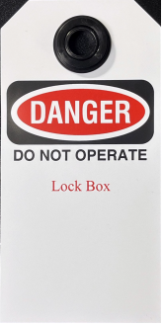

Figure 4. Example of a Controlling Organization “Danger: Do Not Operate Tag”

